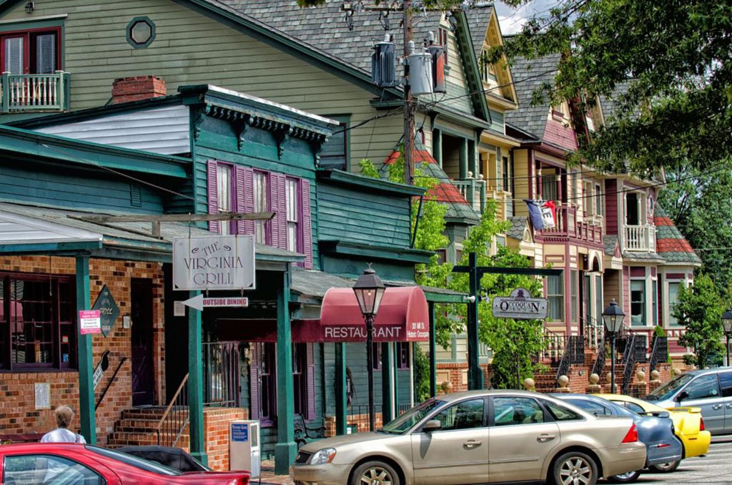

|  |
| --- |
|  |
| RECOMMENDATION SYSTEM TO START A RESTAURANT BUSINESS IN NORTHERN VIRGINIA |
| February 8  IBM Applied Data Science Capstone Project  Authored by: Reeva Bhatkal |

Contents

I. INTRODUCTION 3

Background Discussion 3

Problem Description 4

II. DATA 5

# INTRODUCTION

## Background Discussion

“Northern Virginia” (NoVA) is an area within the Commonwealth of Virginia and is part of the Washington DC metropolitan area. It is located in the northeastern part of the Commonwealth of Virginia, along the borders of Maryland and Washington, D.C. It provides recreational opportunities for a wide range of interests and lifestyles. From sports teams in all major leagues to historic landmarks, national and state parks, rivers, ample retail options, and cultural offerings, the region boasts a quality of life that attracts residents and visitors.

Northern Virginia is considered one of the country’s most international regions and has the highest number of ethnic groups and nationalities represented in Virginia. Close proximity to the nation’s capital provides all the advantages of accessibility to key federal agencies, with a competitive edge of highly skilled talent at cost-competitive wages. Northern Virginia’s unique blend creates an ideal environment for all types, from recent graduates eager to live in a diverse urban environment to families looking for comfortable housing solutions in the nearby suburbs. It is one of the fastest growing, diverse communities in the United States.

In recent years, restaurants are slowly becoming a driving force in Virginia’s economy. They provide jobs and build careers for thousands of people and play a vital role in local communities throughout the state. There are over 15,000 eating and drinking establishments in Virginia, with annual sales over $18 billion. In the state, there are over 378,000 restaurant and food service jobs – 9% of total employment in Virginia. Nationwide, restaurant industry reported sales of $863 billion in 2019 (up from $590 billion in 2010). The industry is on the move, having added 3 million jobs since 2009 and expected to add 1.6 million new jobs by 2029.

Considering Northern Virginia’s diversity and ethnicity it is evident that starting a restaurant business would earn you more money comparatively than most of the other businesses. Although, with more profitable business there comes the most competition. This article can serve as one of the guides to start a restaurant business based on a particular cuisine like Indian, Italian, American, etc., by providing a specific location. The number of restaurants in a specific location categorized based on cuisine and population distribution based on ethnicity and culture are some of the features considered for analysis.

## Problem Description

Opening a restaurant is an exciting and challenging business proposition and choosing the right location can help drive success. Northern Virginia has achieved exceptionally strong local economy and high quality of life through its focus on economic development efforts of the community. These efforts have resulted in the counties being the largest and strongest economy in the Washington Metropolitan Area.

Restaurants are not only a valuable piece of our economy but was identified as a top initiative where there were opportunities to optimize the usage of cross agency resource and service to improve the experience for the restaurateur. In a dynamic market like Northern Virginia, prospective business owners should expect excellence in operations and customer services.

It is evident that to survive in such competitive market it is very important to strategically plan and various factors need to be studied to decide on location such as:

* Population and demographics
* Type of Restaurant (Dine-in, Carryout, Drive-through)
* Who are the competitors in that location?
* Your Target Market
* Restaurant Concept (Franchise, new-concept restaurant)
* Location

And the list goes on…

Success Criteria & Target Audience:

The objective is to locate and recommend stakehoders, which neighborhood of Northern Virginia will be the best choice to start a restaurant business based on cuisine. The success criteria of the project will be a good recommendation of neighborhood choice based on lack of such restaurants considering cuisine as a factor in that location and a suitable target audience who has the purchasing power.

# DATA

To build a recommendation model, following datasets and information are considered for analysis:

* There are 95 counties and 39 independent cities in Virginia. To segment the districts and explore them, we will essentially need a dataset that contains the 95 counties and the latitude and longitude coordinates of each neighborhood. This dataset exists for free on the web. Link to the dataset is: <https://data.opendatasoft.com/explore/embed/dataset/geonames-postal-code@public-us/table/?sort=place_name&q=US&refine.admin_name1=Virginia>
* Data provided by the United States Census Bureau from <https://www.virginia-demographics.com/counties_by_population> is utilized to get more insights about Northern Virginia city and counties. The data provided knowledge about the population density, immigrants' country of origin and many more.
* We will be using Foursquare API to get information about available restaurants for a given city and county in Northern Virginia. The API also provided information about restaurant styles based on cuisine.